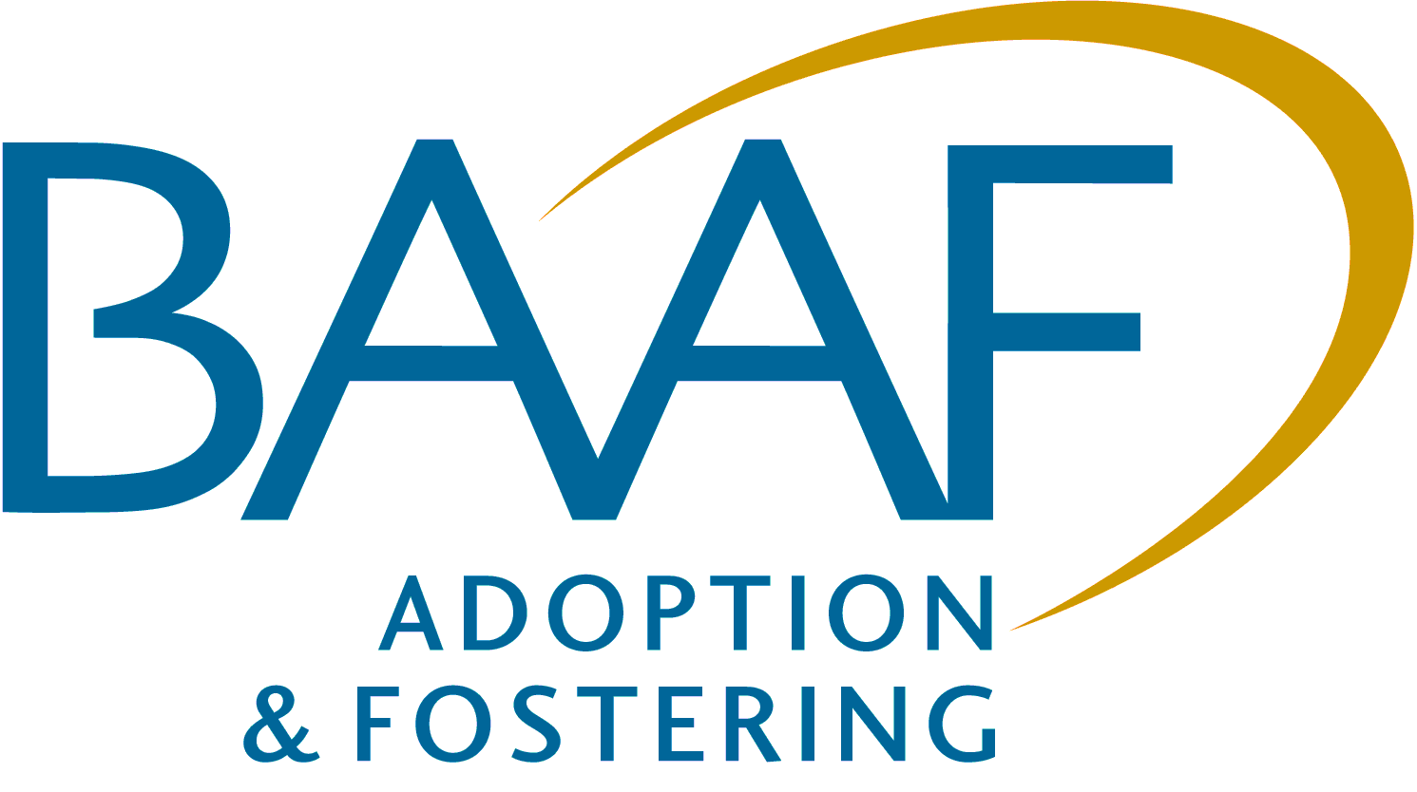
British Association for Adoption & Fostering

4 Pavilion Business Park, Royds Hall Rd, Wortley, Leeds LS12 6AJ
T: 0113 289 1101 E: dfetraining@baaf.org.uk
www.baaf.org.uk

ONE-DAY SEMINAR
Offering an Effective Adoption Support Service
Sept 2014 – Nov 2014
Birmingham, Bristol, Leeds, London, Manchester, Newcastle
Times

Registration - 9.45am
Start - 10.00am
Close - 3.00pm
Who should attend?

People who can assist in the dissemination of the workshop materials to your adoption service.
Other

Refreshments / Lunch provided.

The Department for Education has contracted BAAF to run free seminars over 2 years, starting in July 2013 to support the adoption reform programme. These sessions are available to all registered adoption agencies and registered adoption support agencies in England.
There will be a series of four seminar topics offered through regional workshops over 2 years broadly covering the areas set out below. Each adoption agency can have a maximum of eight free places to be used across the workshop programme (Two free places/seminar topic).
- The Adopter Assessment process (July-September 2013)
- The role of Fostering for Adoption and Concurrency in care planning (November 2013 -January 2014)
- Writing robust and effective child care reports for the court and permanency planning (April – June 2014)
- Offering an effective Adoption Support service.
The impact of delay on a child’s development is a theme running through all the seminars.

Workshop 4 (September – November 2014)
Offering an Effective Adoption Support Service Seminar
Aims
- Explore the adoption support framework, its implementation, and its further development in policy and law.
- Consider the:
- principles for assessment for, and the provision of, adoption support services (including an introduction to newly developed Adoption Support Assessment toolkit);
- social workers’ roles in engaging with the family to develop a perspective on their primary issues of concern; and,
- process for the formulation of the adoption support plan and provision of services.
- Share best practice and identify an action plan for the development of local adoption support services.

For details on when and where these seminars are taking place, see the registration form on page two. Please tick the box for the seminar you would like to attend. Numbers on the seminars are limited depending on the venue, and bookings will be made on a first come first serve basis, with two places initially available per agency. If your agency wishes to book more than two places then they can do so at an additional cost.
SEMINAR REGISTRATION FORM
Offering an Effective Adoption Support Service

Monday 1st September 2014 –BAAF Head Office, London
Friday 5th September 2014 – BAAF Leeds Office
Tuesday 23rd September 2014 – BAAF B'ham Office
Wednesday 24th September 2014 – The Heatons, Manc
Monday 29th September 2014 – BAAF Head Office, London
Wednesday 1st October 2014 – BAAF Newcastle Office
Tuesday 7th October 2014 – BAAF Leeds Office
Friday 17th October 2014 – BAAF Head Office, London
Monday 20th October 2014 – CCS Adoption, Bristol
Monday 20th October 2014 – The Heatons, Manchester
Thursday 23rd October 2014 – BAAF B'ham Office
Wednesday 29th October 2014 – BAAF Head Office, London
Wednesday 5th November 2014 – BAAF Newcastle Office
Thursday 13th November 2014 – BAAF Head Office, London
Friday 14th November 2014 – BAAF Leeds Office
Tuesday 18th November 2014 – BAAF B'ham Office
Thursday 20th November 2014 – CCS Adoption, Bristol
Thursday 27th November 2014 – The Heatons, Manchester

Please note that approximately one week prior to the date of the seminar, we will either:
- send a confirmation email with joining instructions or
- notify you by email that the seminar has been cancelled.
Name (place 1): |  | Agency name & address:
Position (place 1):
Name (place 2):
Position (place 2): |  | Billing Address (if different to above, and applicable):
Special diet/disability:
Telephone:
E-mail addresses:  (We will send your confirmation via email, so please write clearly and double check the spelling) |  | Billing e-mail address:
 |  | (NB. All invoices are sent by email)
We will store your details and may want to contact you in the future with more information about our services and activity.
Please cross box if you do not want us to do this. We will not pass your information on to a third party without your permission. Data Protection Act 1998.
Fee for additional place (above the allocated free places per agency or independent persons or non-registered adoption/adoption support agencies wishing to attend) £95.00 (+ VAT £19.00) = £114.00
Remittance enclosed – Cheque (including VAT) payable to ‘BAAF Registered Charity‘
Please invoice: - Purchase Order Number: __________________________

In the event of a cancellation, I agree to pay a cancellation fee as detailed below.
Substitutions and cancellations - Completion of this booking form is a binding agreement. Substitutions are welcome at any time.
BAAF reserves the right to levy a fee in the event of cancellation. More than six weeks prior to the event 25% of the fee; between two and six weeks 50%; less than two weeks 100%. Nonattendance at a seminar after registration, still counts towards your allocation of free places, you will not be able to transfer your booking without prior consent from BAAF.

If you are unable to attend please let us know ASAP so we can allocate your place to someone else.
Please return all completed registration to BAAF Northern England (post or email):
4 Pavilion Business Park
Royds Hall Rd, LEEDS
West Yorkshire, LS12 6AJ
Tel: 0113 289 1101 E-mail: dfetraining@baaf.org.uk

(Please note that confirmation that a registration form has been received is only sent if requested)
British Association for Adoption and Fostering is a registered charity. Nos. 275689 (England and Wales) and SC039337 (Scotland)
Registered as a company limited by guarantee in England and Wales. No. 01379092. Registered office at 6-10 Kirby Street, London EC1N 8TS

