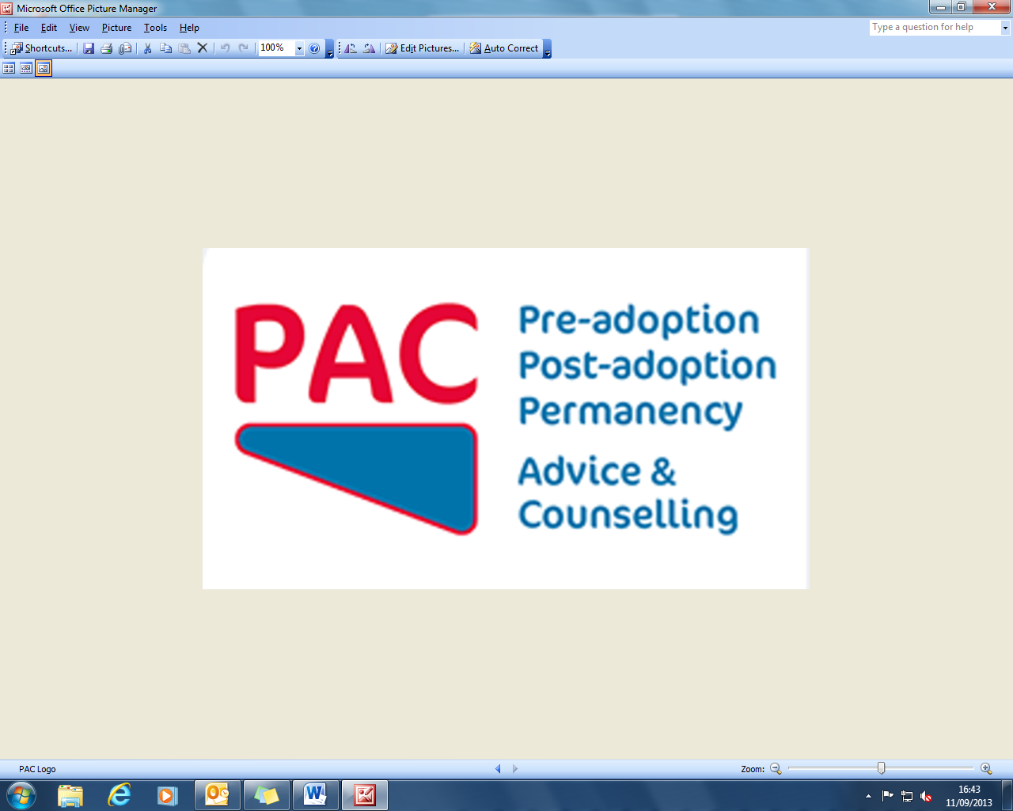

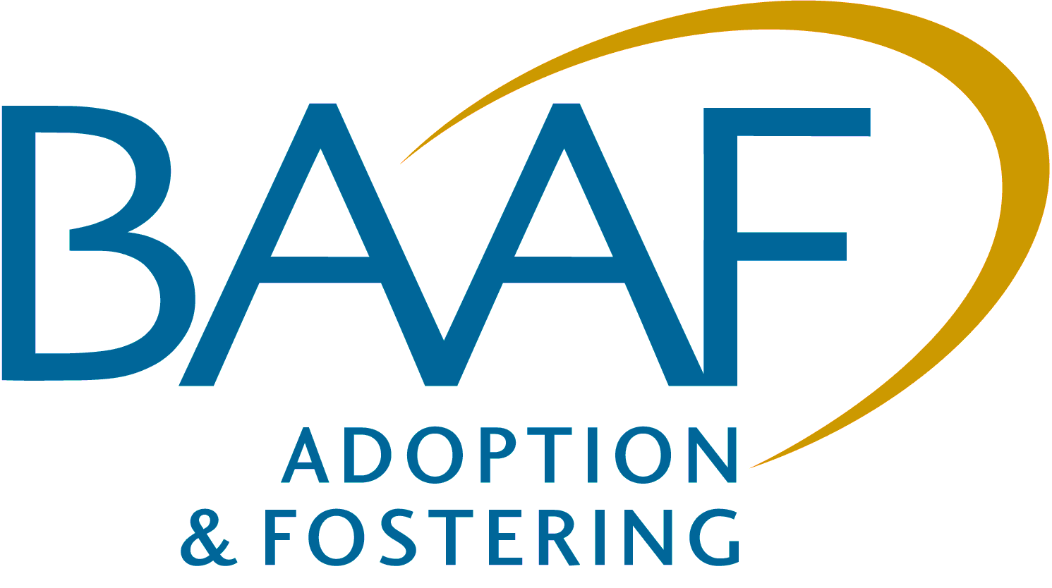

**What is the evidence base for effective mental health interventions for looked after and adopted children?**  
  
  
A one-day workshop with Michael Tarren-Sweeney  
Associate Professor of Child & Family Psychology  
University of Canterbury, New Zealand

Friday 18 October 2013, 10am – 4pm, BAAF, London

**THEME**

The workshop will be conducted by Michael Tarren-Sweeney who has established an  
 international reputation for his studies of the development of adopted and fostered children. In a soon to be published book he summarises his views *"My plea to researchers and clinicians alike is to stay mindful of the centrality of enduring, loving relationships for children’s psychological development and well-being, and the role this can play in their recovery from mental ill-health – even when their difficulties appear incompatible with normal family life. With this in mind, treatment goals for children in care and adopted children should at the very least include: Reducing symptoms that are subjectively distressing and/or impair children’s social functioning; Increasing children’s felt security and sense of well-being; Strengthening children’s relationships within loving, permanent families, or (if their present placement is necessarily impermanent), strengthening their capacity to form and sustain meaningful relationships with a permanent family".*

**AIMS**

* To consider the current evidence base for effective interventions with adopted and fostered children
* To explore the range of interventions and their component parts.
* To explore how treatment goals should be set based on agreed assessments of clinical need.
* To explore the framework for understanding the effectiveness of planned interventions.
* To share good practice.

**WHO SHOULD ATTEND?**

The workshop is designed for all professionals whose work involves the  
  
 assessment of the needs of adopted or fostered children or providing services to address their needs and those of their adoptive parents or foster carers.

**Venue:** BAAF Head Office, Saffron House, 6 -10 Kirby Street, Farringdon, London EC1N 8TS

**Timings:** Registration9.30am, Start 10.00am, Close 4.00pm Refreshments/lunch provided

**Facilitator:** Michael Tarren-Sweeney



**What is the evidence base for effective mental health interventions for looked after and adopted children?**

A one-day workshop

Friday 18 October 2013  
  
  
A One-Day Workshop with Michael Tarren Sweeney

Thursday 17 October 2013 London



**REGISTRATION FORM**

|  |  |  |
| --- | --- | --- |
| Name   Name | | |
| Position | | |
| Organisation | | |
| Address/correspondence | | |
|  | | |
|  | Postcode | |
| Telephone | Fax | |
| Email: please provide for an email confirmation  Email: please provide for email confirmation and to be kept informed of future events | | |
| Requirements (e.g. dietary, disability access) | | |
| Your purchase order number | | |
| Billing address/invoice | | |
|  | | |
|  | |  |
| □ We will store your details and may want to contact you in the future with more information about our services and activities. Please tick the   box if you **do not** want us to do this. We will not pass your information on to a third party without your permission. Data Protection Act 1998. | | |

**Fees**

* £85 + vat (includes lunch and refreshments)

**Method of payment** (BAAF VAT No. 235 376458)

* Invoice
* Remittance enclosed – sterling cheque (including VAT) payable to *‘BAAF Registered Charity*‘
* Debit my MasterCard / Visa / JCB / Maestro / account with the amount of £___________________

Card number________________________________________________ Expiry date_______________ Valid from date _______________  
  
  
  
  
Issue number (Maestro only)___________________________________ 3 digit security number__________________________________  
  
  
  
Signature_________________________________________________________________ Date _______________________________

**Substiutions and cancellations:**

Substitutions are welcome at any time. BAAF reserves the right to levy the following charges in the event of cancellation:   
more than six weeks prior to the event 25% of the fee; between two and six weeks 50%; less than two weeks 100%.

Please return your completed form to

Danielle Sawyer, BAAF, Saffron House, 6-10 Kirby Street, London EC1N 8TS.

T: 020 7421 2647 F: 020 7421 2601 E: danielle.sawyer@baaf.org.uk

Registered as British Association for Adoption and Fostering. Registered Office,   
Saffron House, 6-10 Kirby Street, London EC1N 8TS. A Company Limited by Guarantee.   
Registered Number 01379092 (England and Wales) Registered Charity 275689   
(England & Wales) and SC039337 (Scotland) www.baaf.org.uk

BAAF and PAC (formerly the Post Adoption Centre)