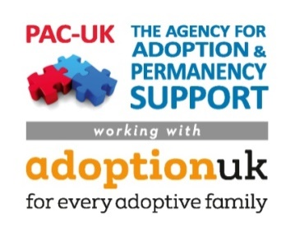[](https://www.google.co.uk/url?sa=i&rct=j&q=&esrc=s&source=images&cd=&cad=rja&uact=8&ved=0ahUKEwicqLzO_f3RAhUHXBQKHfgjDvwQjRwIBw&url=https://khub.net/events/-/event/view/16265853?_events_WAR_eventsmanagementportlet_eventUid%3D8_PORTLET_16265853&psig=AFQjCNEr95Y0Pl_zSDnll6MZ0mu2dUnfLA&ust=1486556754035630)

Community Meetings for Virtual Schools, Schools,   
Local Authorities and Adoptive Parents

PAC-UK, Adoption UK & the Department for Education  
Working together to support adoptive families in schools

As part of our investment in supporting adoptive families, the DfE has awarded a grant to PAC-UK and Adoption UK to develop and implement strategies with school staff, virtual schools, local authorities and adoptive families to improve the adoptive family’s school experience and therefore increase their child’s academic and personal success. Please join us in making this change by giving your input and joining with others at our Community Meetings.

What are community meetings?

PAC-UK is organising a local space where virtual schools, adoptive parents, school staff and local authorities will come together to dispel myths and build connections in order to support the educational achievement and experience of adoptive and permanently placed children.   
  
This collaborative forum will combine skills and experience to make long-lasting sustainable changes to the way adopted children are supported within the borough.

Community Meetings will focus on:



* The challenges faced by all parties
* Strategies for moving forward
* Sustainability

Who should attend?

The meetings are aimed at a range of different practitioners, as well as parents, in order to aid the working relationship between these groups who all have a similar goal; to improve the educational and emotional outcomes of adopted and looked after children. Virtual School head teachers, designated teachers from schools (or any practitioner involved in the education of adopted or looked after children) and adoptive parents are all welcome at our Community Meetings.

Further information

For further enquiries (incl. bookings) please email Lisa O’Callaghan at lisao@pac-uk.org and for more information on PAC-UK’s Education Service visit www.pac-uk.org/education

